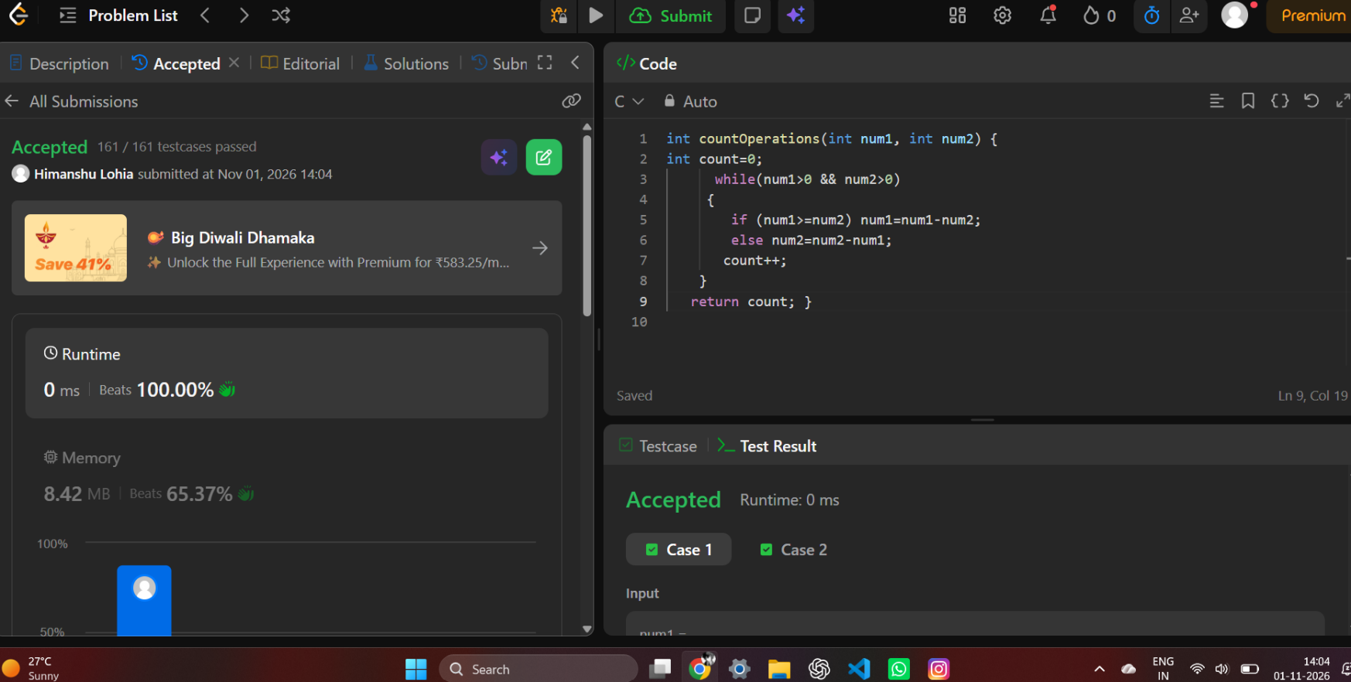
https://leetcode.com/problems/count-operations-to-obtain-zero/description/

int countOperations(int num1, int num2) {
int count=0;
while(num1>0 && num2>0)
{
if (num1>=num2) num1=num1-num2;
else num2=num2-num1;
count++;
}
return count; }

